OPINION
Did an antiracism shift break Boston’s best charter schools?
Their decline has become a test case in the culture war over education.
By Steven F. Wilson and Charles Chieppo Updated June 23, 2026, 3:00 a.m.
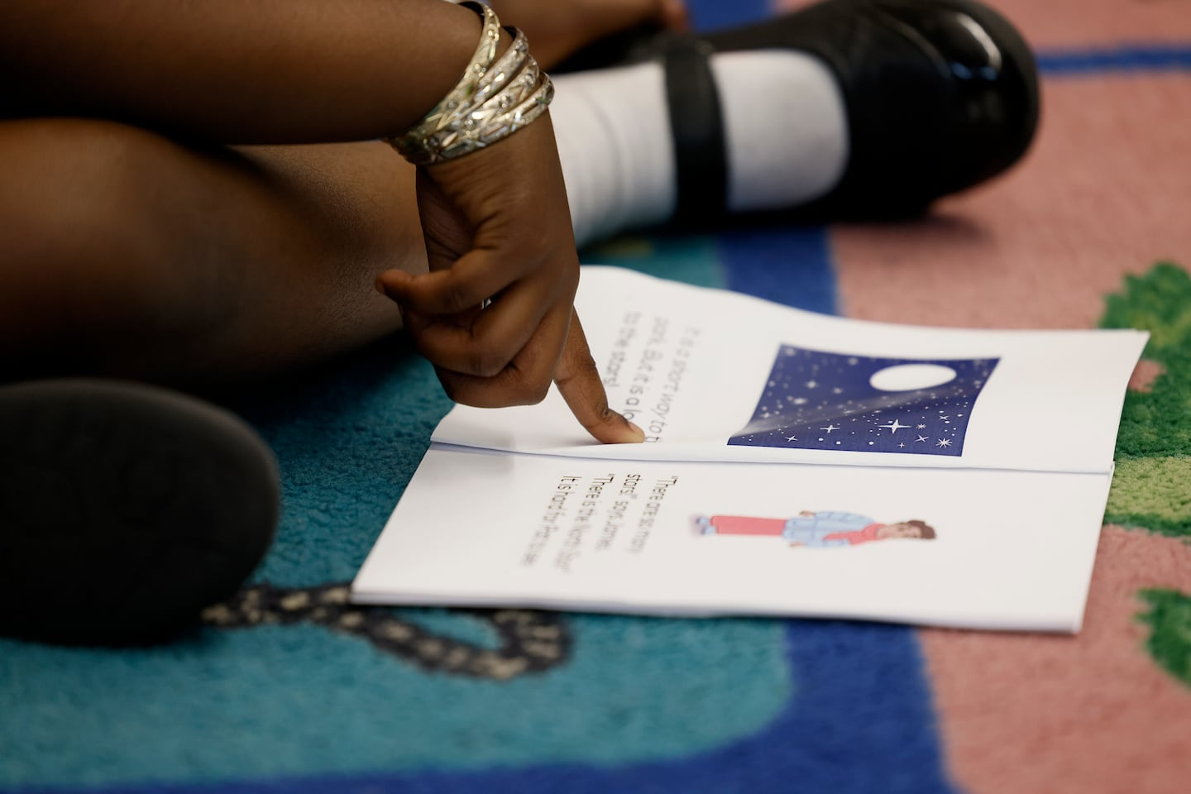A child read during her kindergarten class at Brooke Charter School in Mattapan on May 30, 2023. Jessica Rinaldi/Globe Staff
Steven F. Wilson and Charles Chieppo are senior fellows at Pioneer Institute. Wilson is the author of “The Lost Decade: Returning to the Fight for Better Schools in America” and an accompanying “Charter School Toolkit.”
Urban school reform was working. Did antiracism break it?
We have sought to advance diversity, equity, and inclusion in public education for decades. For us, that means a diverse staff, a multicultural curriculum, inclusive school communities where children feel known and heard, and most importantly, academic achievement for all students.
In the 2010s, new schools dedicated to educational equity were posting striking results. When the Center for Research on Education Outcomes at Stanford University examined student outcomes from 2015 to 2019 in 29 states as well as Washington, D.C., and New York City, it identified some 200 charter school networks serving urban areas that were closing — or even reversing — longstanding achievement gaps in reading, math, or both.
“More critically,” the authors wrote, “there is strong evidence that these gap-busting schools can be scaled.”
Indeed, the Charter School Growth Fund, a nonprofit organization that funds high-performing charter networks, reported in 2021 that the schools in its portfolio were together adding 50,000 students annually — equivalent to opening a new district larger than the Boston Public Schools.
Boston’s charter schools were among the best of them. A 2016 report from the Brookings Institution found that “test-score gains produced by Boston’s charters are some of the largest that have ever been documented for an at-scale educational intervention.”
Longtime education reformer Orin Gutlerner remembers visiting one of the high-fliers, Roxbury Preparatory Charter School, as a young middle school math teacher in 2001. He’d received state commendations for his own teaching, but when he stepped into a seventh-grade classroom in the school he was astonished. “I thought I held a high bar for teaching,” he said in an interview. “But what these students were doing, their engagement, the pace of the teaching — it absolutely blew me away.”
But it wasn’t to last.
From 2019 to 2023, the percentage of students in Boston’s charters that met or exceeded expectations on the state’s 10th-grade math exam fell by 19 percentage points. In the Boston Public Schools, the drop was only 8 points.
Why did charter achievement tank? To be sure, charter teachers struggled with COVID-19 pandemic-related learning loss, increased screen time, and rising mental health concerns. But so did educators everywhere. It was not external challenges that derailed charters. It was forsaken commitments.
The racial reckoning that followed the 2020 police murder of George Floyd could have accelerated the transformation of urban public schools, where most of America’s historically marginalized students are educated. Instead, it dealt reform a body blow.
For two decades, teachers at Boston’s high-performing charters had pledged never to make excuses for low achievement. They would do “whatever it took” for their students to succeed. Safe and orderly classrooms, high expectations, engaging curricula, precisely crafted lessons, and more time to learn set every child on the path to college and career.
But in the 2010s, as identitarian ideology reached its apex on college campuses, newly minted teachers questioned the schools’ practices. Were white teachers who ensured disciplined classrooms and expected all students to go to college engaging in a neocolonialist project that enforced “whiteness”? A pamphlet widely circulated among the charters seemed to offer the answer. It held that the “worship of the written word,” “perfectionism,” and “objectivity” were all toxic “characteristics” of “white supremacy culture.”
The charter schools’ longer school days, disciplinary systems, and standardized testing to gauge student progress were similarly cast as racist. Academic expectations were lessened and curricula, even in math, rewritten to foreground social inequities. Before holding students to behavioral expectations and delivering a rigorous curriculum, teachers needed to address students’ “trauma” from growing up in a racist society. The approach was an inexhaustible excuse for failure.
Racism is real and learning about it must be part of every child’s education. But antiracist programming (also known as social justice education) turned instruction therapeutic and political, robbing students of the essential tool of influence — a richly academic education.
One experienced Boston educator reports that many of the foundational practices that drove the highest-performing Boston charters have been removed. In one school, for instance, where homework was once given daily and its timely completion tracked, teachers were told not to assign homework more than twice a week.
Yet one charter network stood firm in its belief that the surest route to social justice was to provide its students with a rigorous liberal arts education.
Boston’s Brooke Charter Schools in Roslindale, Mattapan, and East Boston have become a haven for charter educators dismayed by the changes at their schools. They offer rich curricula, exceptional professional development, and high salaries. In 2023, 70 percent of the network’s eighth graders were proficient in math, compared to a quarter of students in the Boston Public Schools. Brooke’s 2023 results actually improved from 2019, before the pandemic struck.
Education reform has taken a grievous wrong turn. It’s time for Boston’s charter schools — once at the vanguard of reform — to again ensure that every student is afforded effective instruction, high expectations, and a vibrant curriculum. It’s time to stop telling students what to think and to invite them to spar with ideas not their own.
To at last build an equitable and inclusive society, we must afford every American the leg up long granted the privileged: an expansive liberal arts education.

